 | Weekly Team Task Report | #10

Team: GeoLearn |  |  |  |  |  | Date: 3/30/2020
Project Title: Improving elementary education with custom online enironmental science lectures

 | Samuel Prassse  Present  On-time |  | Kaitlyn Grubb  Present  On-time |  | Tyler Pehringer  Present  On-time |  |  | Joshus Tenakhongva  Present  On-time

Recent Meetings:
- General Team Meeting
- Sponsor Meeting

TASKS COMPLETED since last meeting:
Task Title: Documents for Slides | Task Initiation: 3/23 | Orig. Due Date: 3/27 | Status: In Progress
Who (%): Kaitlyn (100%)
Description: Kaitlyn will be working on the docuements for the slideshow presentations. The docuements will contain a small Wiki snippet about the animal and provide it to the teacher along with the completed presentations.
Expected Outcome: Useful teachers notes that can be used whil presenting the slides.

Task Title: Python Script | Task Initiation: 3/23 | Orig. Due Date: 3/27 | Status: In Progress
Who (%): Samuel (100%)
Description: Samuel will be working on a Python script that will grab the video from the google drive, convert it to a gif, and reupload it to the google drive.
Expected Outcome: A quick and optimized process for adding GIFs to our presentations.

This week’s Tasks: Work plan for coming week

Task Title: Database differences | Task Initiation: 3/23 | Orig. Due Date: 3/27 | Status: In Progress
Who (%): Joshus (100%)
Description: Joshus is looking into the differences that he finds between the Animaps database, and our database.
Expected Outcome: Determine why their data is so different than the ones we currently have.

Task Title: Continue website design | Task Initiation: 3/9 | Orig. Due Date: None | Status: In Progress
Who (%): Tyler (100%)
Description: Tyler will continue to develop the design of the website through meetings with Dr. Doughty and Roo.
Expected Outcome: A sleek website that conforms to the sponsor’s specifications.

Upcoming Tasks: Planning
Task Title: Dry Run Pres Videos | Who (%): Team (100%) | Rough Due Date: 4/10
Description: I will install a “submitter” ***ON THE BBLEARN SITE*** (not our regular website!) for the class, where you will upload your presentation video. I will then download all the videos submitted, and place them in a shared folder (likely Google Drive) that everyone can see.

Task Title: Grading Presentations | Who (%): Team (100%) | Rough Due Date: 4/13
Description: Over the weekend, all teams will review and “grade” *three* other team presentations. I will provide a grading sheet for you as a template, and I’ll specify which teams each team reviews. This will help you see what others are doing…and help them improve it…which will help you gain insights to improve your own presentation. It’s a team exercise; I recommend teams assign everyone to watch the assigned videos, then get together on Zoom to collaborate on reviewing/grading them and writing up the review. DUE DATE: by Monday, at 5pm, you will email your reviews to (a) the team leads of the reviewed teams and (b) CC your team mentor. The team mentor will grade your reviews for completeness, thoughtfulness, quality of recommendations given.

Task Title: Poster Due by COB | Who (%): Team (100%) | Rough Due Date: 4/19
Description: There is one more important change. As you know, every team has to prepare a poster and present that poster at Capstone. In the “virtual UGRADs” concept the organizers have come up with, UGRADs runs (virtually) for a *week* from 4/20-4/24…and they had wanted all posters and presentations by the 19th. We Capstone faculty pushed back saying you can’t deprive Capstone teams of a week, and got the 3/23 deadline through. But your POSTERS will be due by end of business on the 19th, so they can be part of the show and be viewed/judged in the poster competition. You will therefore want to be drafting your poster in the next few weeks as well, and reviewing it with your mentor. This is not a huge change from normal…just rules out last minute jobs on the poster.

Task Title: Capstone Final Presentations | Who (%): Team (100%) | Rough Due Date: 4/23
Description: Capstone final presentations are due by end of business on Thursday April 23, the night before the regularly scheduled Capstone. The UGRADs folks promise there will be a way to upload them to the UGRAD site, which will be required. We will also upload them with BBlearn, for easy collection and access by team mentors for grading.

Other Problems / Other Issues:
- Pivoting

Github:

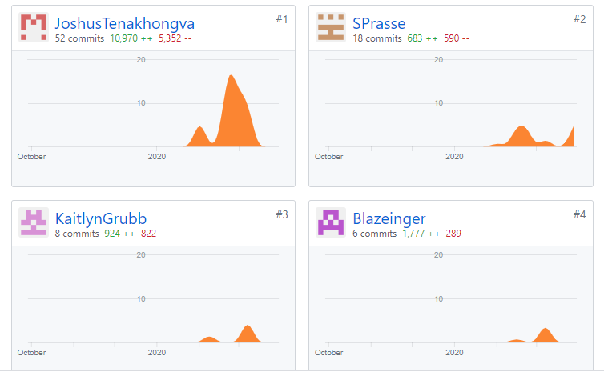

Schedule:
